**TaskController**

@RestController  
@RequestMapping("/v1/task")  
public class TaskController {

**getTasks**

@RequestMapping(method = RequestMethod.*GET*, value = "getTasks")  
public List<TaskDto> getTasks() {  
 return new ArrayList<>();  
}

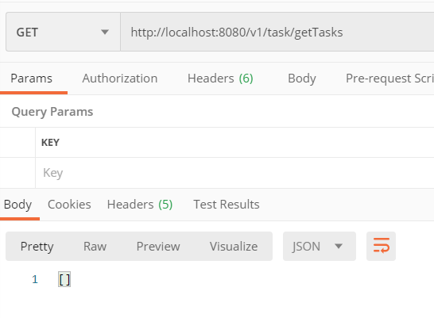

**getTask**

@RequestMapping(method = RequestMethod.*GET*, value = "getTask")  
public TaskDto getTask (long taskId) {  
 return new TaskDto(1L, "test circle", "test_content");  
}

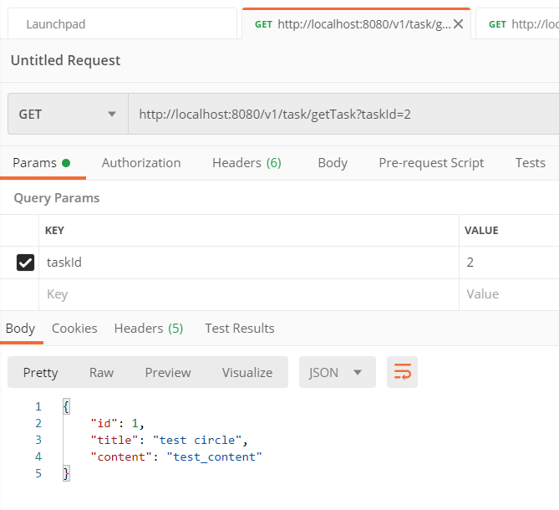

**deleteTask**

@RequestMapping(method = RequestMethod.*DELETE*, value = "deleteTask")  
public void deleteTask (long taskId){  
  
}

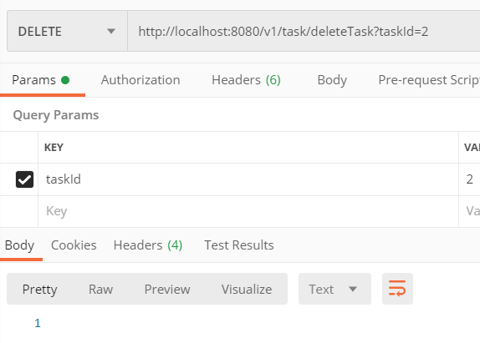

**updateTask**

@RequestMapping(method = RequestMethod.*PUT*, value = "updateTask")  
public TaskDto updateTask (TaskDto taskDto) {  
 return new TaskDto(1L, "Edited test circle", "Test content");  
}

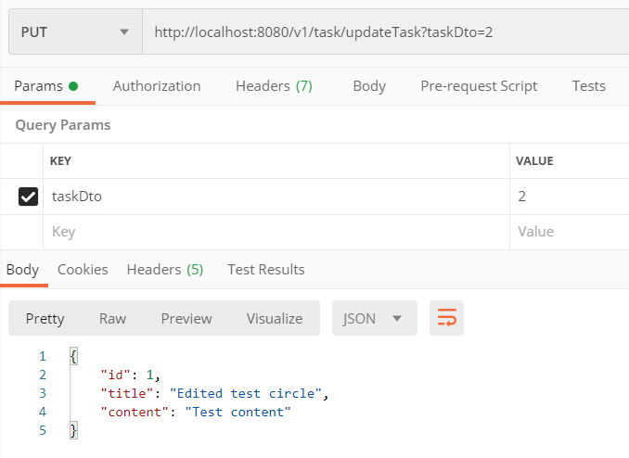

**createTask - corrected**

@RequestMapping(method = RequestMethod.*POST*, value = "createTask", consumes = *APPLICATION_JSON_VALUE*)  
public void createTask (TaskDto taskDto) {  
  
}

